**Install Cisco VPN Client on Windows**

* Go to the folder with the Cisco VPN installers and double-click “GVCSetup . . .” to install first.
* 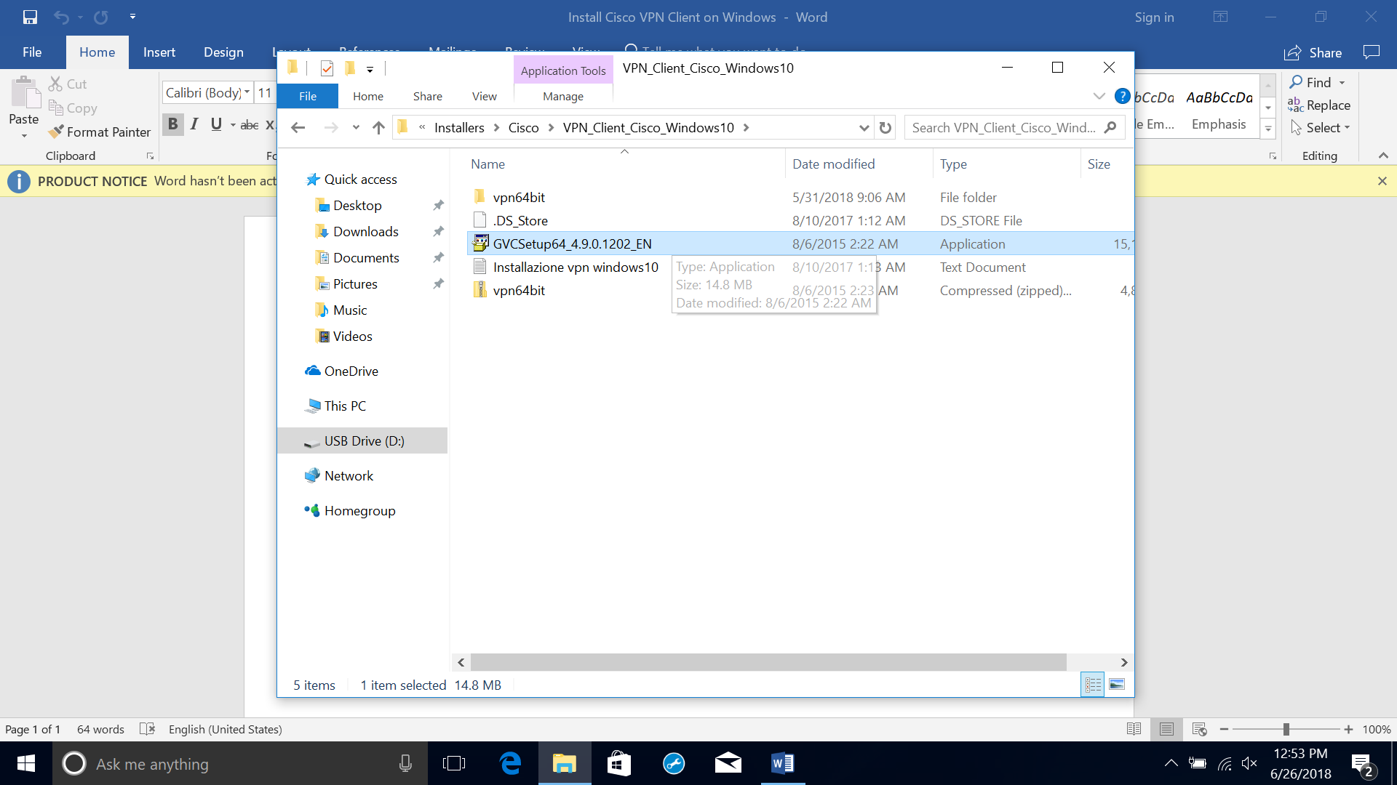
* Double-click “vpn64bit” folder.
* 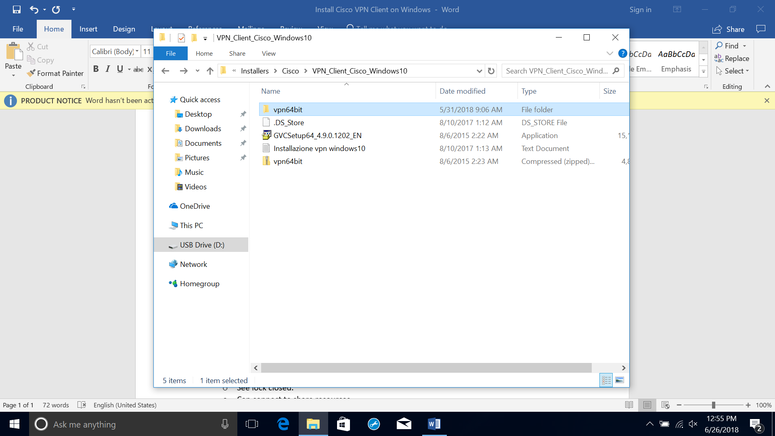
* Double-click “vpnclient_setup” to install next.
* 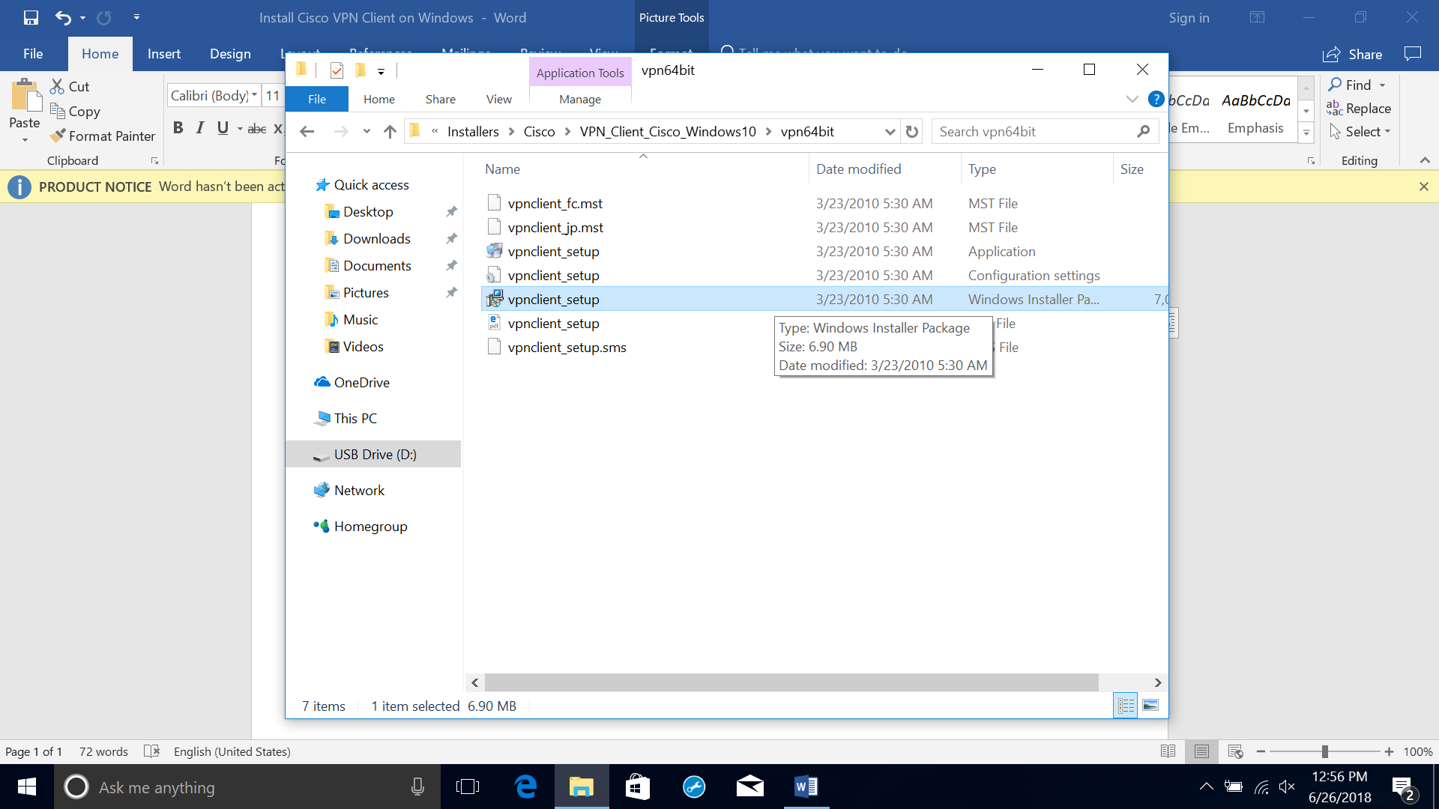
* Press Windows and “R” keys on the keyboard to launch Run window.
* 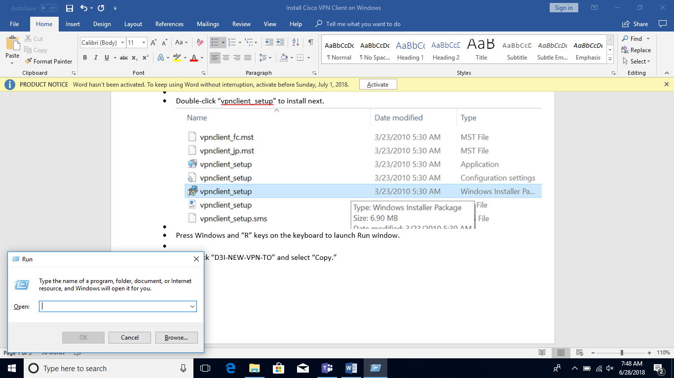
* Type “regedit” into the box and select “OK.”
* 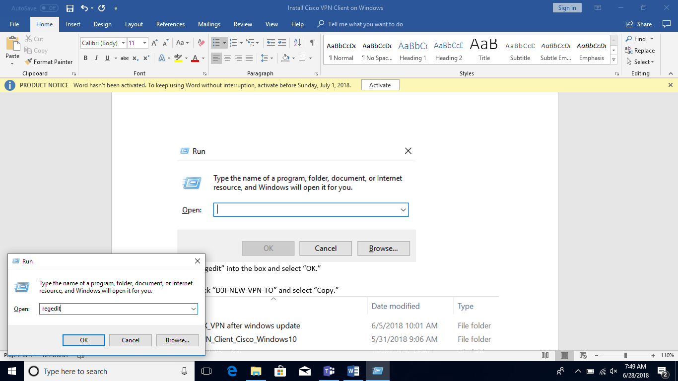
* Expand the folders until you get to “HKEY_LOCAL_MACHINE\SYSTEM\CurrentControlSet\Services\CVirtA”.
* 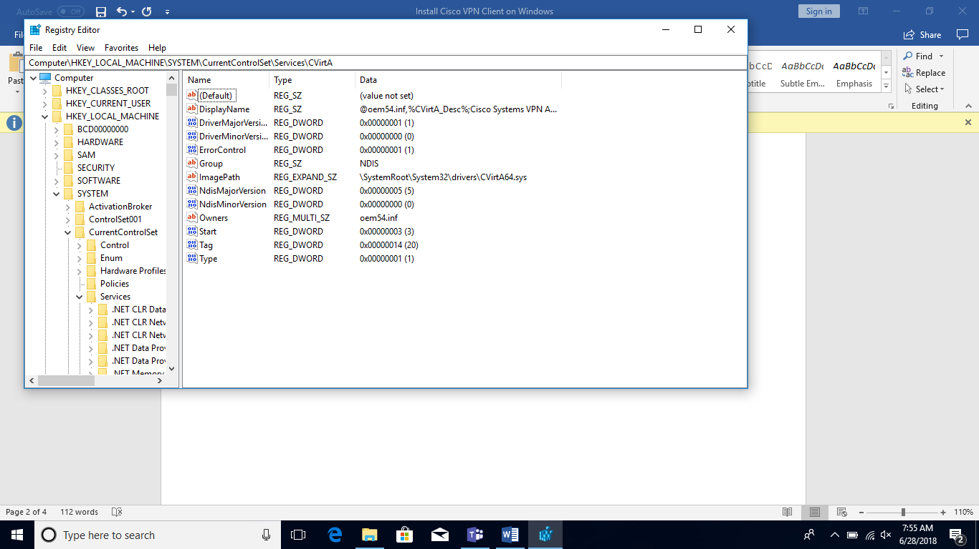
* Right-click “DisplayName” and select “Modify.”
* 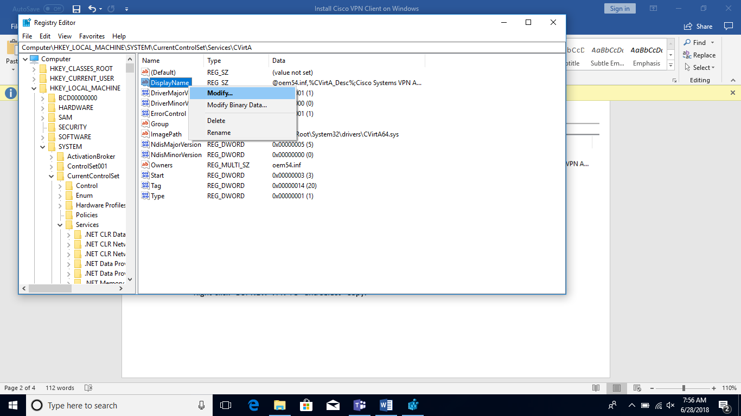
* Change the data in the “Value data:” box to “Cisco Systems VPN Adapter for 64-bit Windows”
* 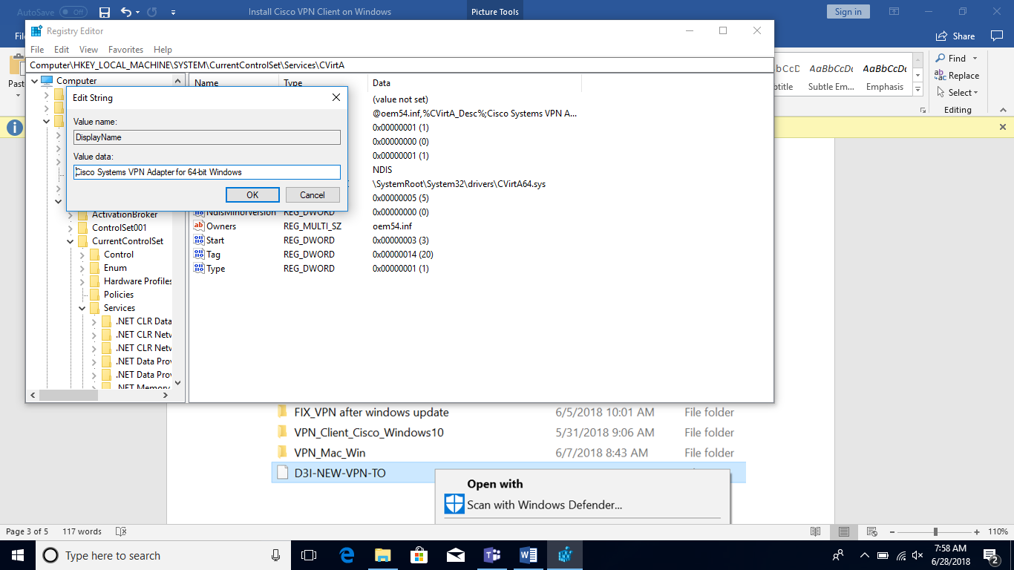
* Return to folder with VPN files and right-click “All-Routes.pcf” and “D3I-NEW-VPN-TO.pcf” then select “Copy.”
* 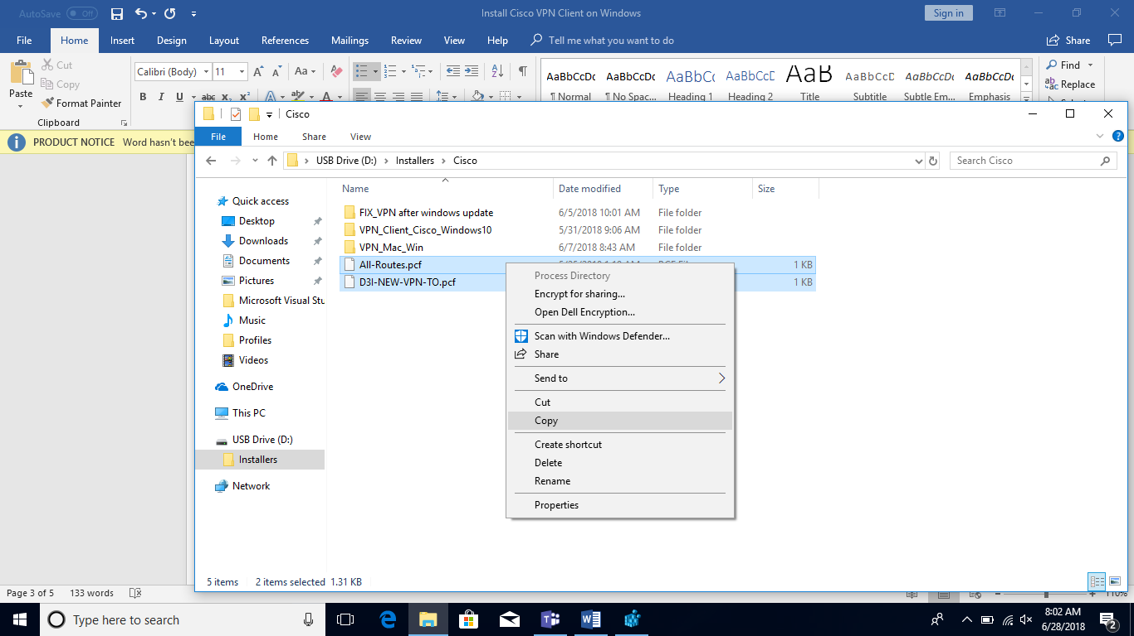
* In File Explorer, go to C:\Program Files (x86)\Cisco Systems\VPN Client\Profiles. Right-click in the folder then select “Paste.”
* 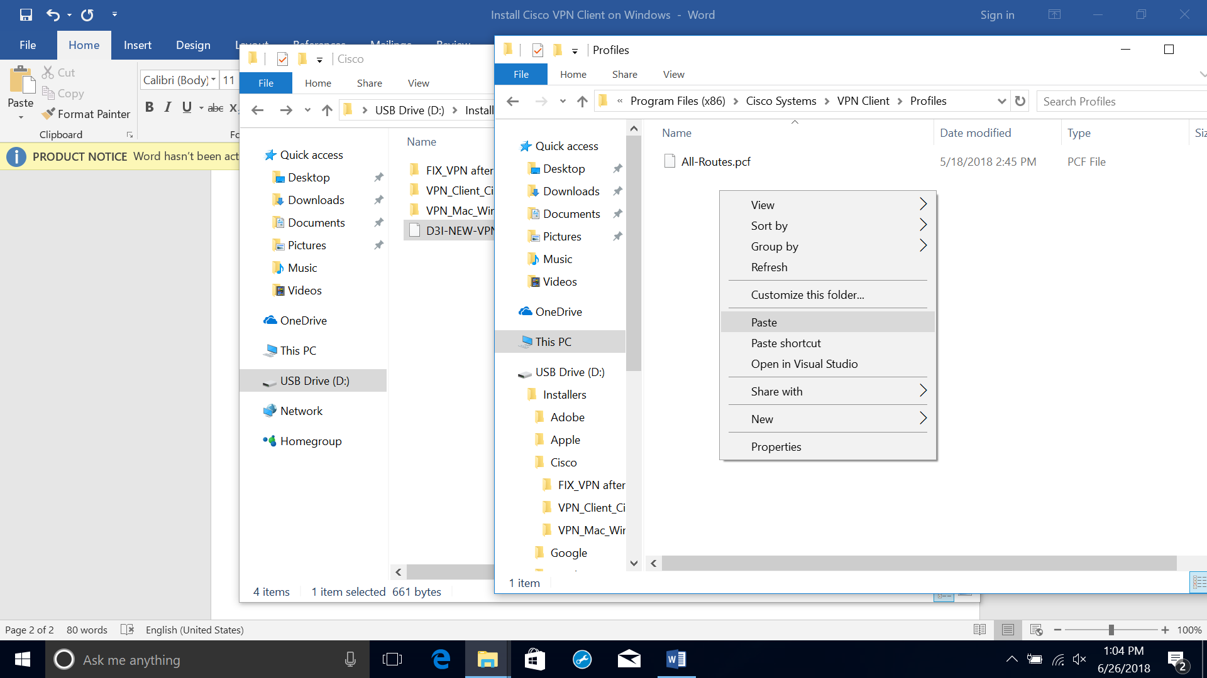
* Launch the “VPN Client.”
* 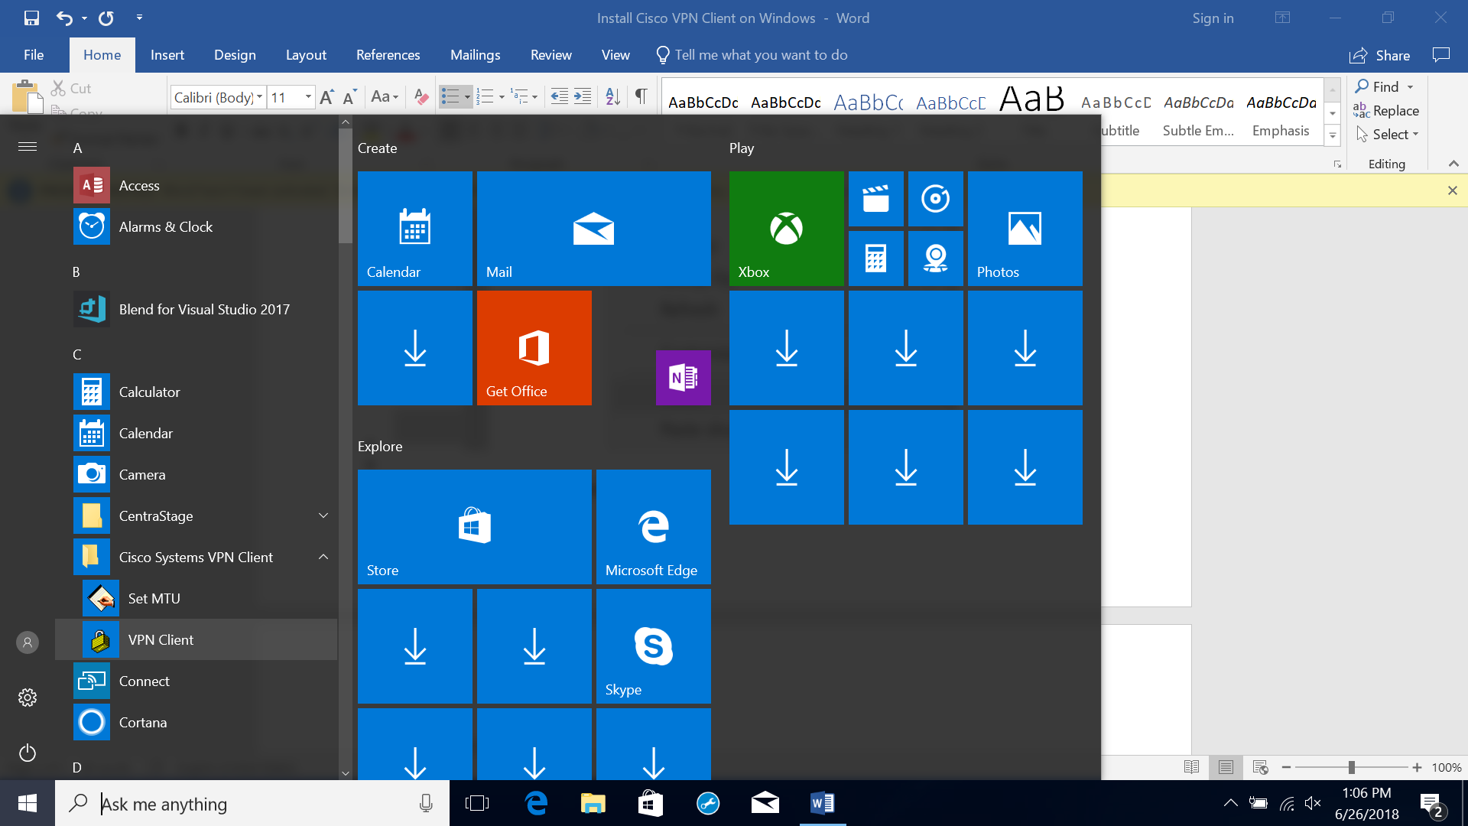
* Double-click “D3I-NEW-VPN-TO.”
* 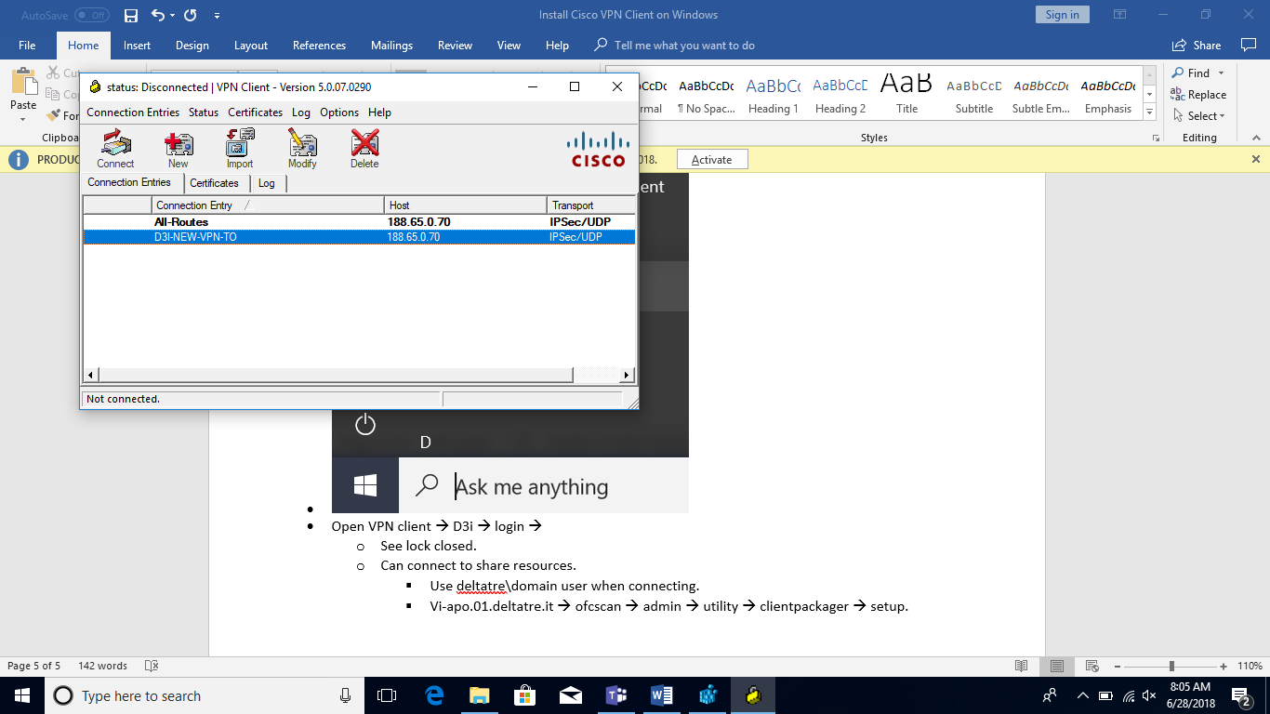
* Sign in with your credentials.
* 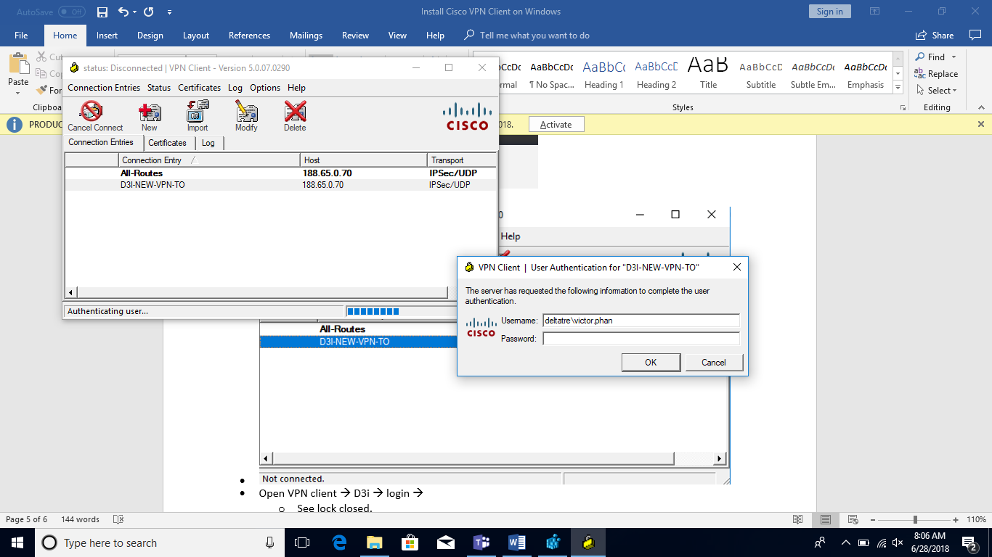
* If you see a lock icon in the tray on the bottom right of the screen then you are logged into the VPN correctly.
* 